**Introduction to NLP | NLP Lecture 1 | End to End NLP Course**

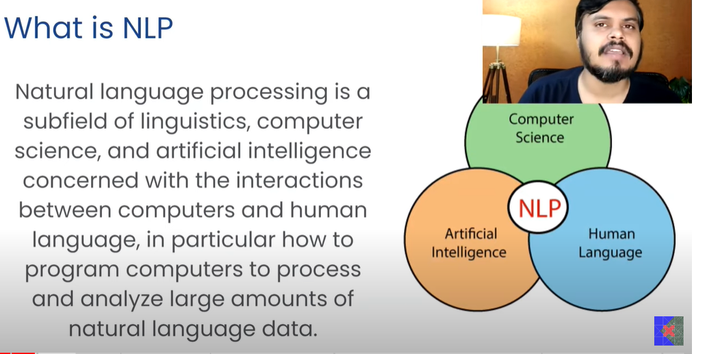

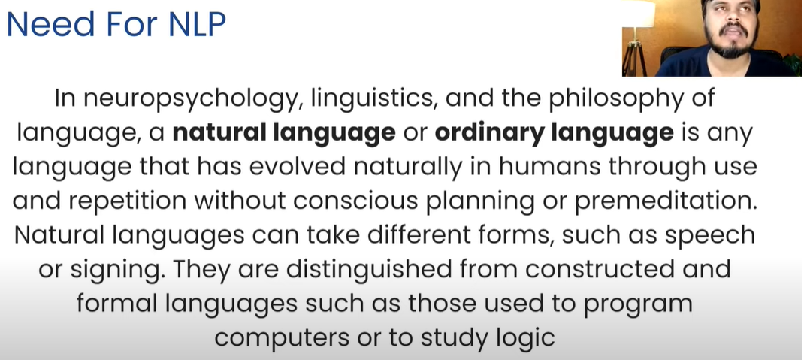

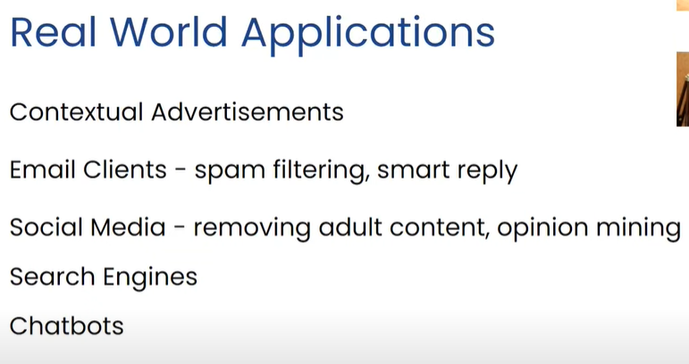

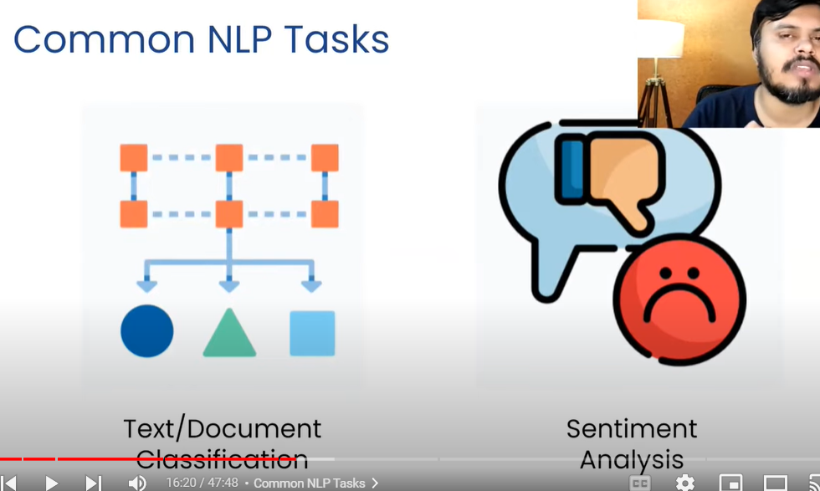

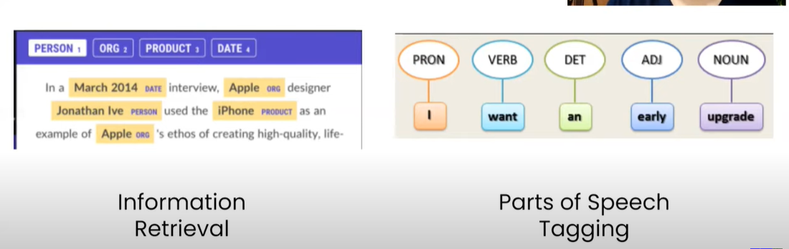

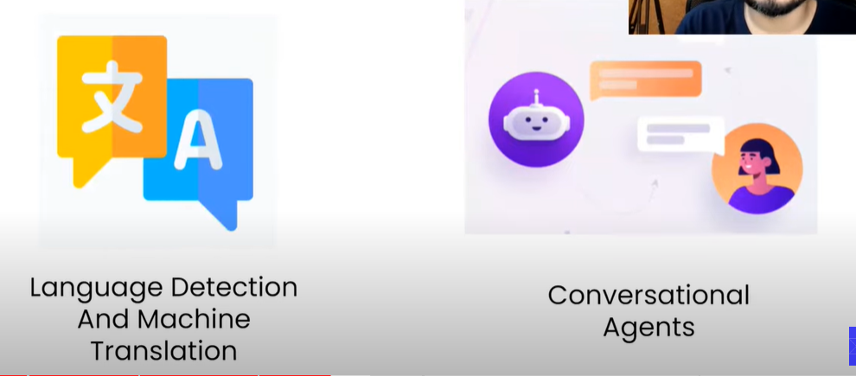

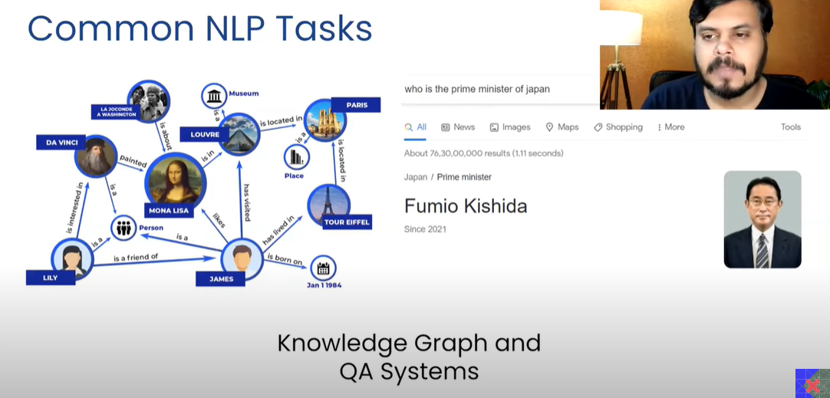

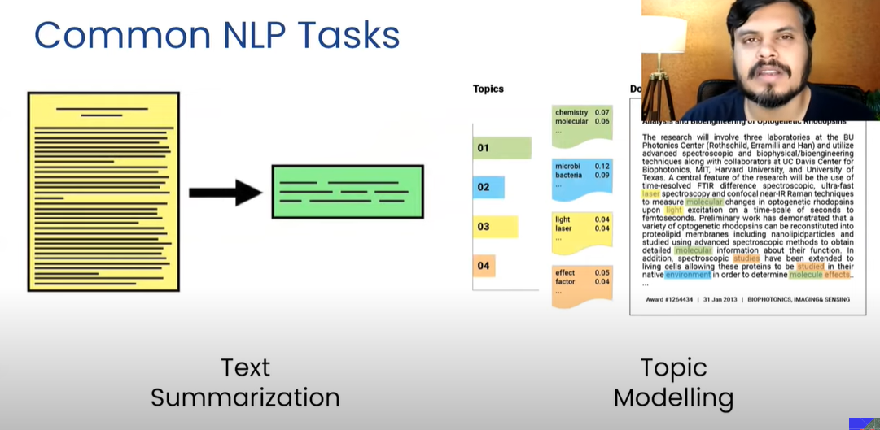

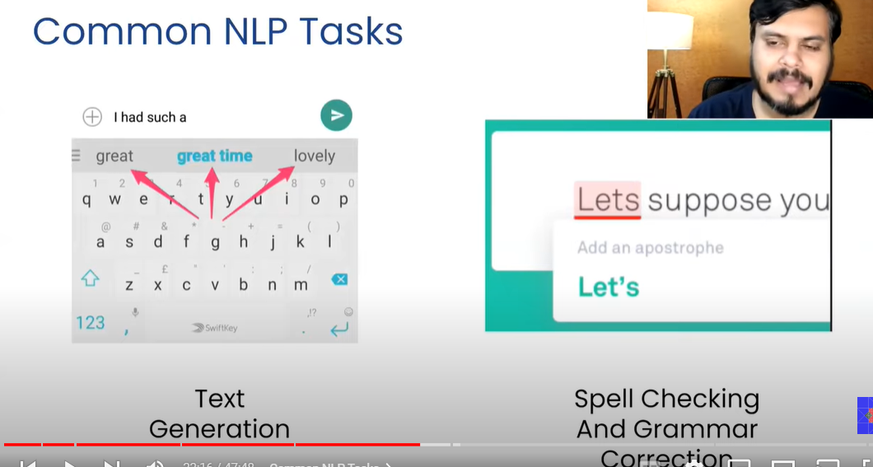

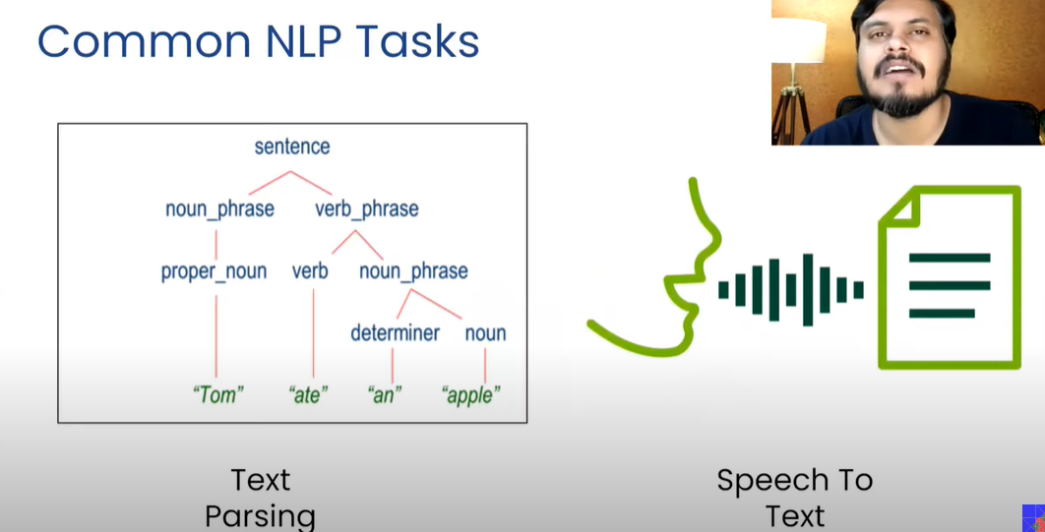

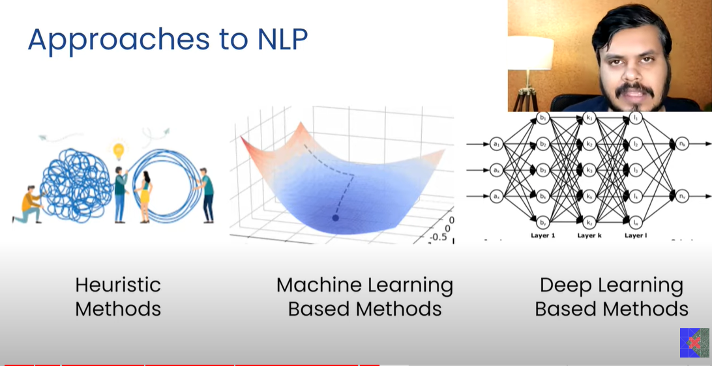



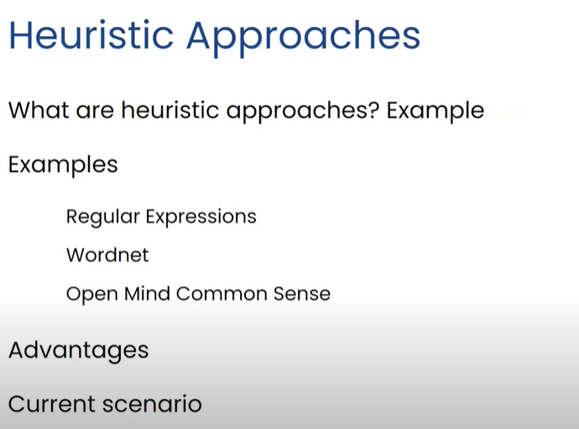

Heuristic approaches are the most common approaches that has been followed by humans using to reach solutions quickly (Jugaad)

These methods are quick but not optimal

Heuristic approaches work based on rules (If-else)

But the problem with Heuristic approach is that it works on certain set of rules that cannot be applied to complex problems (open ended texts)

In those cases we use ML Approach (Converts text to numbers)

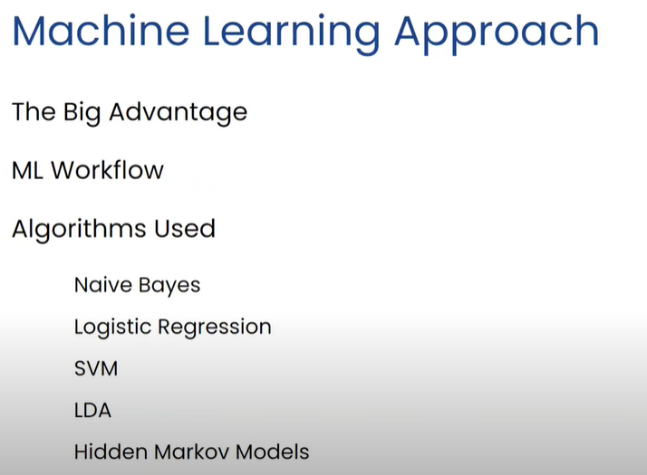

Now the problem with ML approach is that when we convert the textual data to numbers, the sentences might loose the sequence of the words in sentence and which is advantage of deep learning approach. It keeps the sequence intact

In DL feature generation happens automatically in the model, while in ML we have to create the features manually based on our understanding

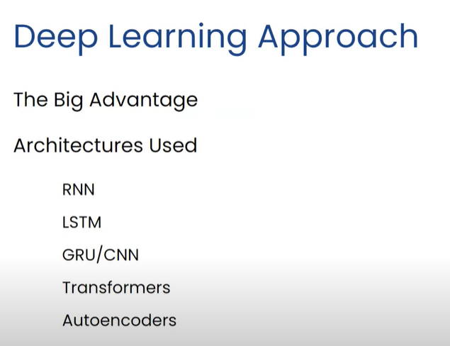

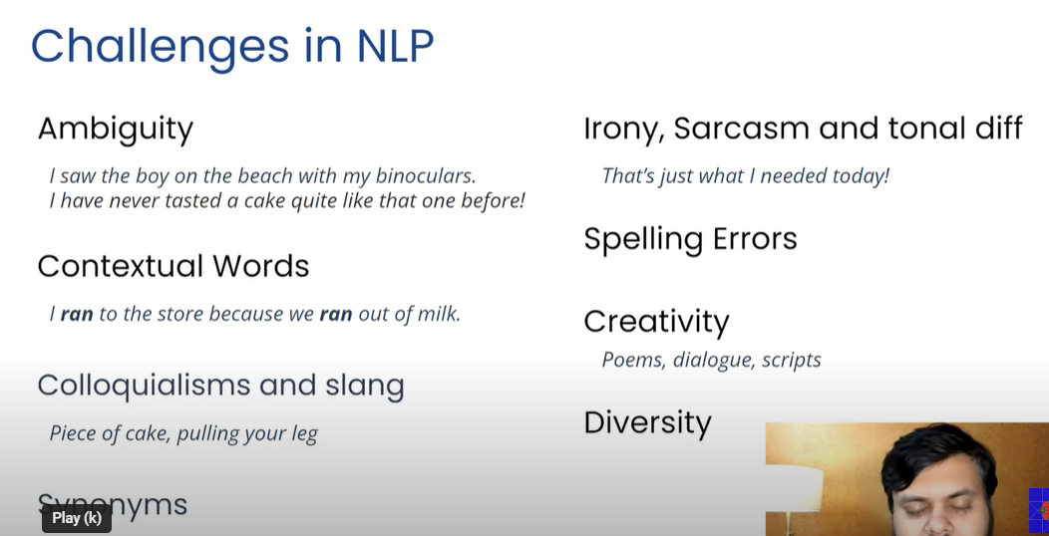

# End to End NLP Pipeline | NLP Pipeline | Lecture 2 NLP Course

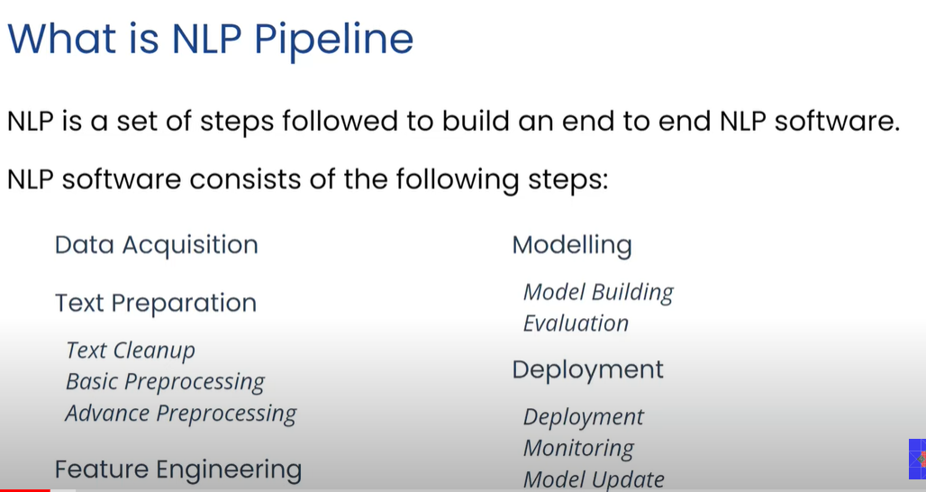

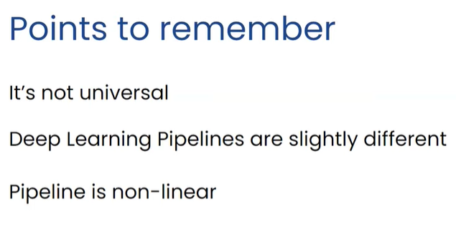

These all steps can be non-linear. For example, we do feature engineering again after we know that we don’t have accurate results

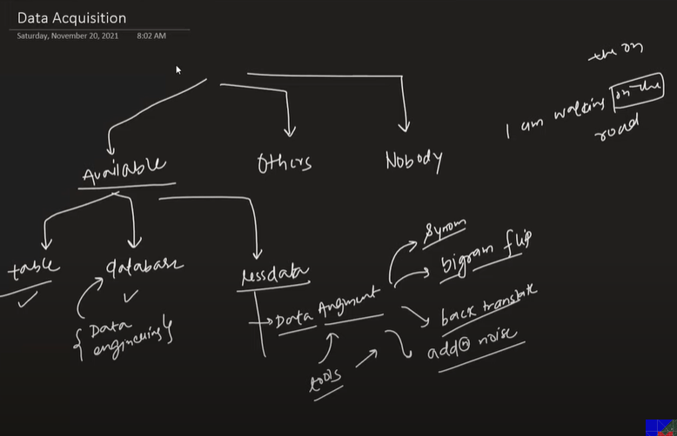

When data is coming from external system

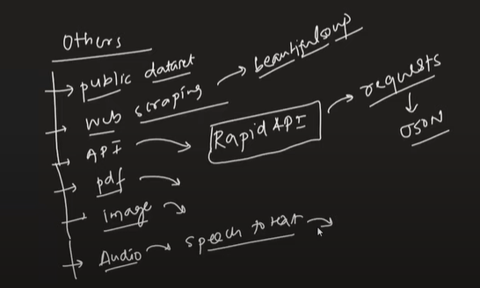

When data is not available, we try to manually extract the data and label them and then apply heuristic techniques such as Regex

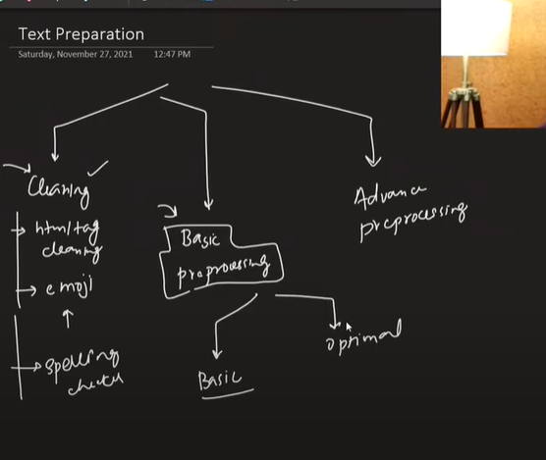

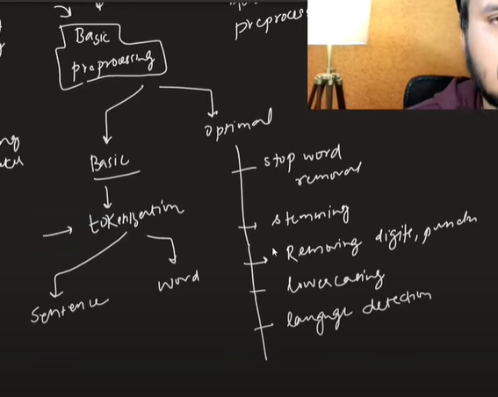

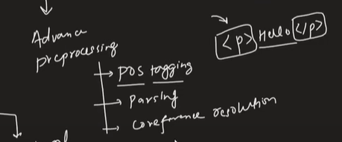

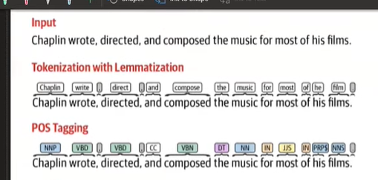

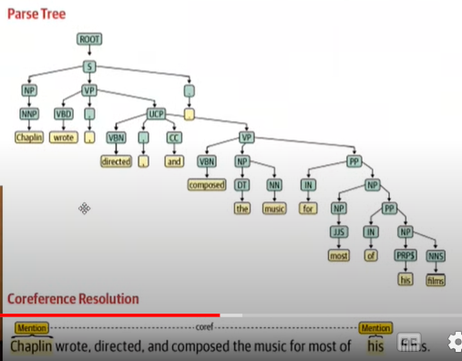

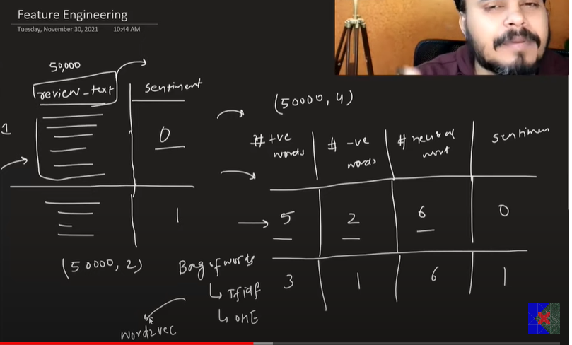

Feature engineering depends upon the use case scenario. We convert the text information in machine readable format

Now we do feature engineering in two different ways in ML and DL

In ML we manually create the features while in DL we just pass the data and algorithm automatically creates the features

Advantage of using ML based algorithm: As we create the features manually we can explain the results and interpretability doesn’t get lose

Disadvantage of ML : We have to create the features manually and for that we need the domain knowledge and the task becomes hectic. Sometimes all the created features doesn’t guarantee that they’ll work in improving the model, some feature may decrease the performance

Advantage of DL: Features can be generated automatically

Disadvantage of DL: Internally we don’t which feature is working well to give us the better results. Features are not interpretable

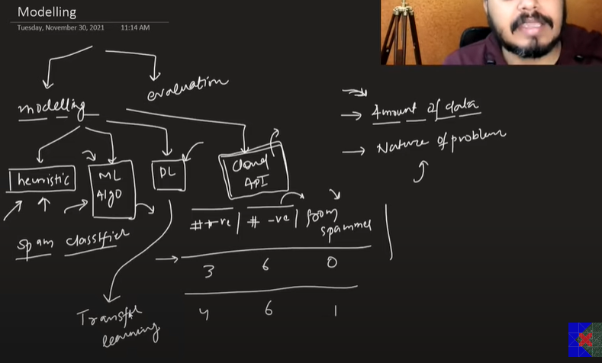

Modelling depends upon the amount of data and nature of problem

When the dataset available is less, we go for the heuristic approach. We manually decide the conditions on which to segregate the textual data

ML/DL algos are introduced when the amount of data is more. Sometimes we can combine both heuristic (for creating certain features) and ML approach to model the data

DL algo require more number of datapoints to give effective results. There is transfer learning approach available in Deep learning (BERT)

Cloud solution is also an option if the available problem can be solved using a cloud

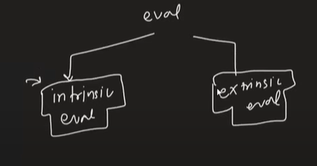

Evaluation are of two types intrinsic and extrinsic evaluation

Intrinsic evaluation is about measuring performance of model internally. However, extrinsic evaluation is about consistently measuring performance of model deployed in the business setting

Let’s take an example of text generation system:

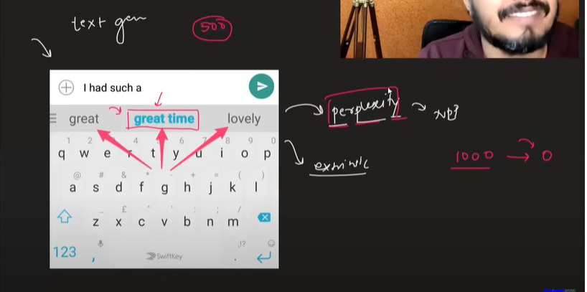

Perplexity in text generation is how much confused the model is

Suppose at intrinsic level, we are sure our model is going to perform and has good accuracy. That doesn’t give us the whole picture. But at extrinsic level, if customers are not even taking suggestions listed on text generation suggestions the model is not successful

But on flipside if the users are using the suggestions most of the time and count is high, then we are sure it is a successful model at both extrinsic and intrinsic level

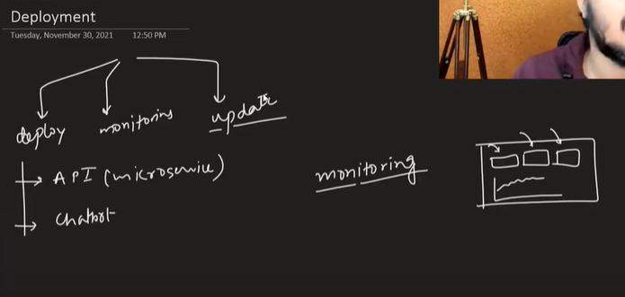

We deploy our model based on customer needs. It can be an API or chatbot

Continuous monitoring of the model performance is done through live dashboards

Updates is re-training the model with new data. Can be done online/offline both

# Text Preprocessing | NLP Course Lecture 3

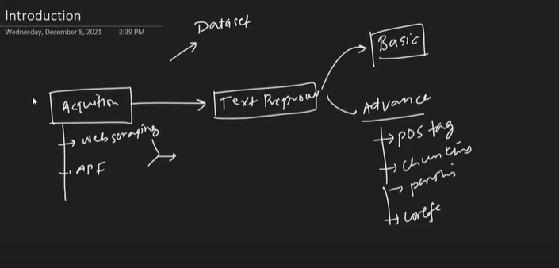

Step 1: Lowercasing to avoid system to differentiate b/w two same words but in different case

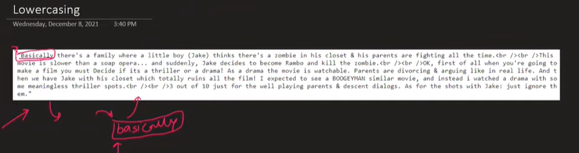

Step 2: Removing HTML tags from the sentences that are scraped from web. We use regex

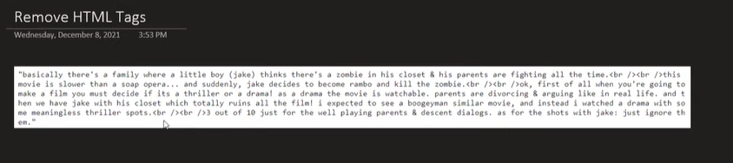

Step 3: Remove URLs : It is good idea to remove URLs and we use regex

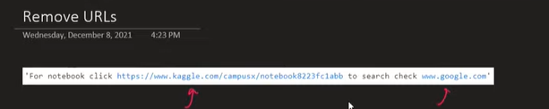

Step 4: Removing Punctuations from the sentences is important as it may create problems while tokenization. It sometimes considers punctuation mark as separate tokens or sometimes it remains with the words which makes it difficult to differentiate b/w two words

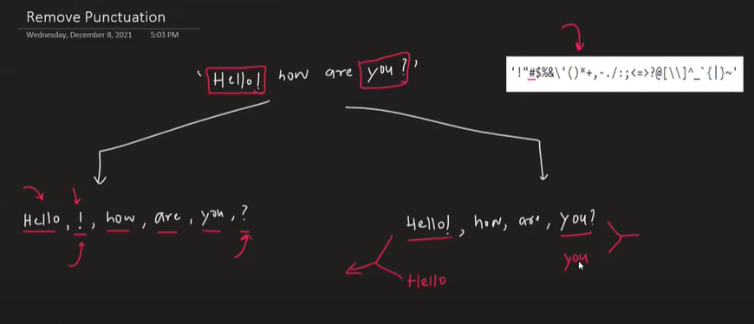

Step 5: Chat word Treatment: Handling shorthand words used while texting

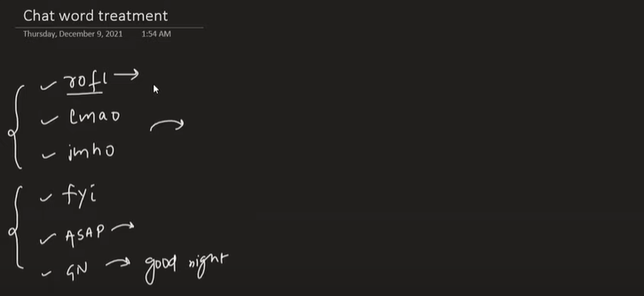

Step 6: Spelling Correction : Correcting the spelling of words (usually same words that are misspelled) which can create complexity while tokenizing and it will consider it as two separate words

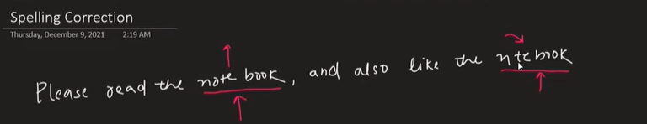

Step 7: Removing stop words that don’t contribute in meaning of the sentence

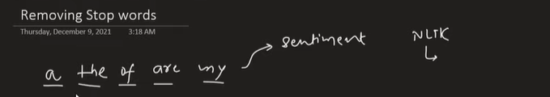

We keep stop words in few scenarios such POS Tagging (Part of Speech Tagging)

Step 8: Handling Emojis : With evolution of text messaging apps, usage of emojis have increased. Usually machines don’t understand emojis. So we either remove them or replace emoji with word that is signifying the feelings

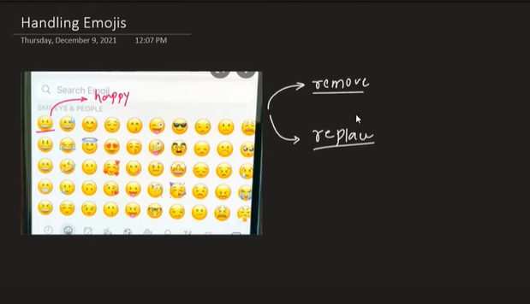

Tokenization

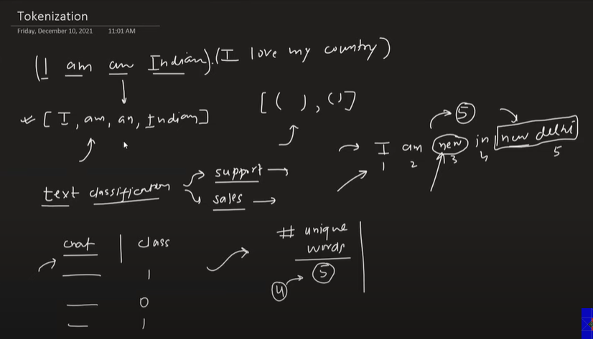

Tokenization is usually done at word level and can also be done at sentence level

We create new feature of unique words using tokenization. Sometimes, the tokens should be separated in such a way that meaning of two same words with different meanings doesn’t change

Some of the challenges are:

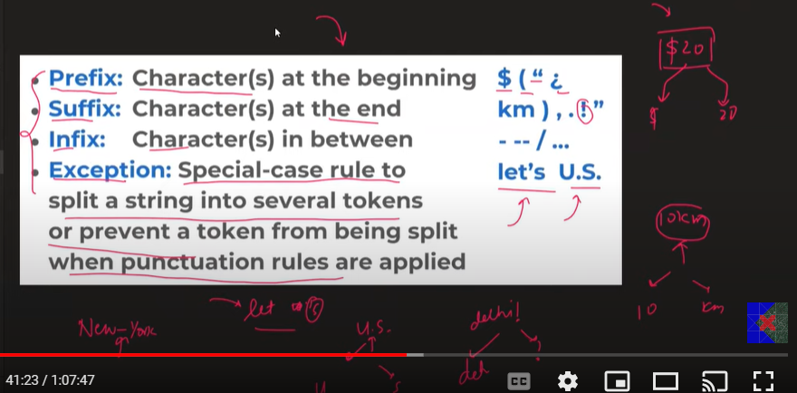

**Stemming**

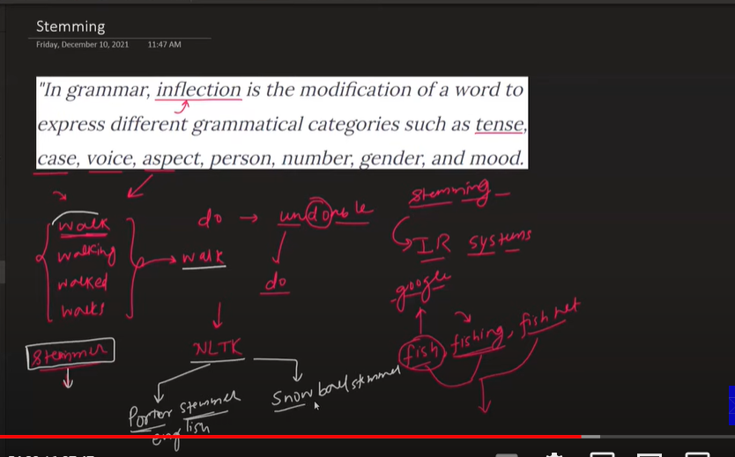

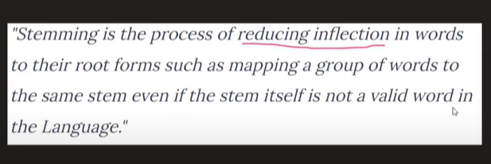

Stemming is used to bring the inflected words back to its root word

There is one drawback with stemming that, sometimes that root word that comes after stemming may not be an actual word in English like favorit, probabl. Hence it is not user friendly to show output to someone



In these scenarios we use lemmatization, which will give the original words after stemming. However, lemmatization is a slow process. Hence, where speed matters and quality of output doesn’t matter we use stemming

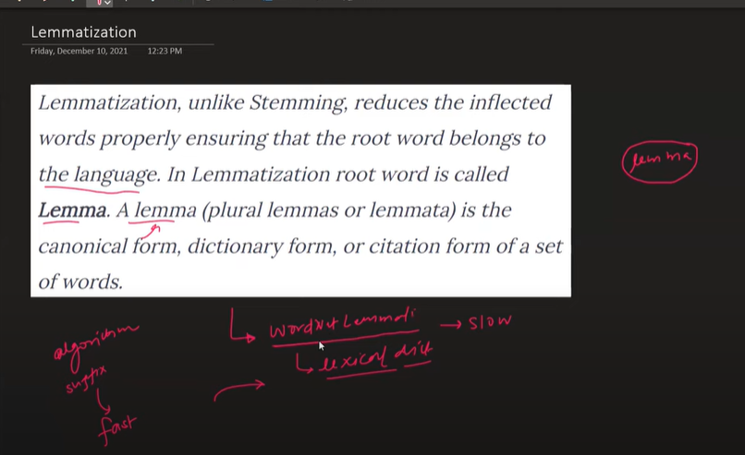

Lemmatization is a slow process because it searches that word individually in the lexical dictionary

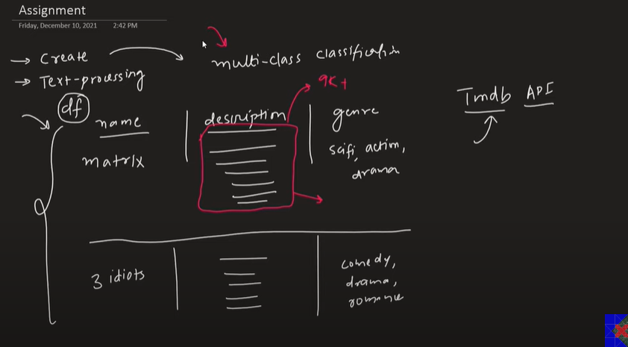

# Text Representation | NLP Lecture 4 | Bag of Words | Tf-Idf | N-grams, Bi-grams and Uni-grams

**What is Feature Extraction from text?**

Text representation or Text Vectorization is also known as feature extraction in which we convert the text in the numbers and represent it into different features

**Why do we need it?**

Our goal is to understand the sentiment behind the text. Hence we convert it to individual features such that we can create output from the machine

In ML based NLP it is very important to create efficient features out of the text

**Why is it difficult?**

It is a difficult task because it is difficult for machines to understand the textual data. They can understand images and speech easily but when it comes to text the task becomes whole lot difficult

**What is the core idea?**

The idea is to convert the meaning behind the text into a number in best possible way which defines the success

We want to convey the semantic meaning behind the text through numbers

Techniques to convert text into numbers:

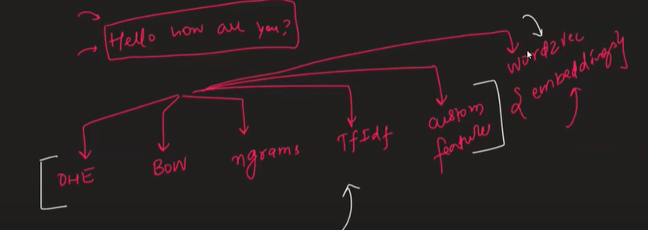

Some of the common terms used:

1. Corpus (c) : It is the total number of words available after we concatenate all the text (reviews)present in all the rows
2. Vocabulary (v) : Number of unique words in the corpus
3. Document (d) : Each sentence or each review will be a document
4. Word (w) : Each word in the sentence is a word

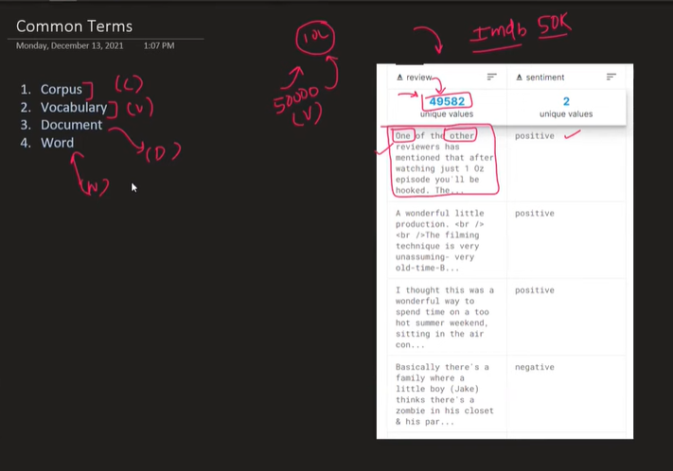

**One Hot Encoding**

As per OHE we convert each word in a document to a v-dimensional (number of unique words) vector

If we have vocabulary of 5 words (5 unique words), we convert each word in a document to 5-D vector

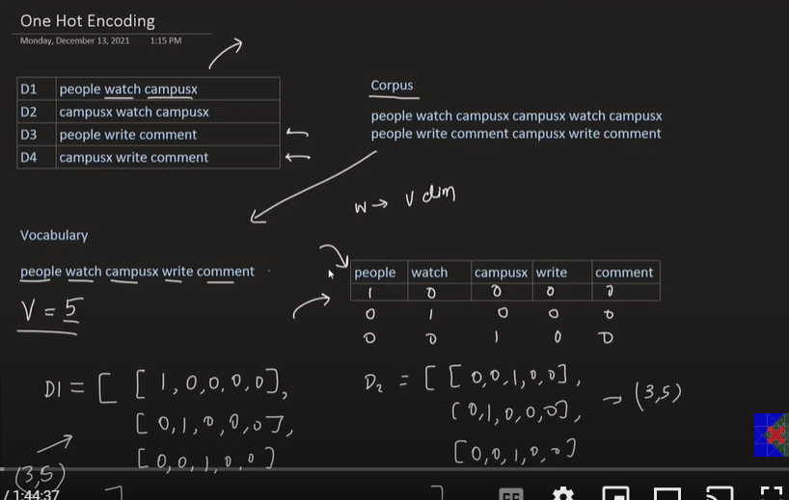

Now OHE is easy to implement and intuitive.

But we don’t use OHE in real time scenarios, because:

1. **Sparsity:** It creates sparsity when the vocabulary number becomes more, more number of rows and columns which has more zeroes and only one column as 1. It tends to overfitting
2. **No Fixed Size:** Suppose the number of words are not consistent in each document then it may lead to different sized array. In these scenarios ML algo will fail as it works on same size dataset

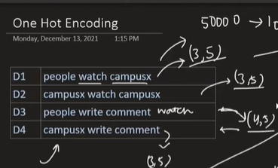

1. Out of Vocabulary:

If some new word comes in a document that is not available in the existing vocabulary of words then it will create problems

1. No capturing of semantic: Since our aim is to capture the accurate meaning and sentiment from the word. Sometimes, OHE doesn’t capture the correct sentiment of the word

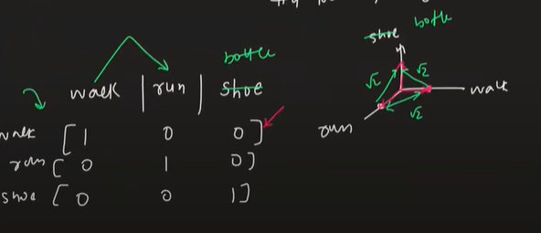

**Bag of Words**

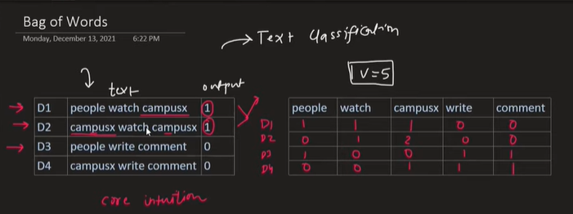

Core intuition behind bag of words is that it classifies the text consisting of similar words at similar frequency as same class

Order of the words doesn’t matter, directly we don’t cover the contextual meaning behind the words. But indirectly, the context is covered

Each document can be converted to a vector in v-dimensional plane (vocabulary numbered dimensional plane) apparently in 5-D plane

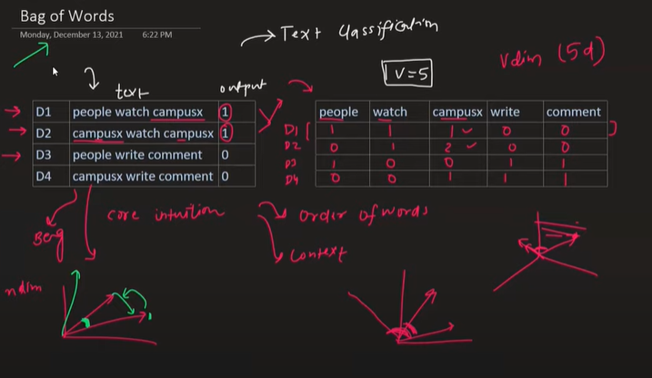

Bag of words also captures the semantic (meaning behind the word or words with similar meaning)

The intuition behind this is that, each vector will be plotted on n-dimensional plane. The similarity b/w the planes is calculated by cos theta b/w two vectors. Closer the two vectors are more similar are the documents (set of words). Both of the similar vectors are classified as same

It can handle the new words that are not in the vocabulary.

We use CountVectorizer() in scikit learn to implement this in python

There is a parameter in CountVectorizer called binary, if we keep binary = False, it will count the frequency of the word but if binary = True then even if the word is coming multiple times the count will still be 1 and rest 0.

In most cases we keep binary = False, but while doing sentiment analysis we keep binary = True

Another hyperparameter is max_feature which is used when we want to eliminate the vocabulary that are rarely used

Max_feature =1 means only the word that is repeating most of the time will be part of vocabulary

Max_feature = 2, only word with that is repeating most of the time and second most of the time will be included in vocabulary

Advantages:

Even if the number of words in a document are not equal, the model will still work

No OOV problem

Partially captures semantic relationship

Disadvantages:

Sparsity problems

Ignores all the words that are OOV

Ordering of words is not considered (which might change the meaning of sentence)

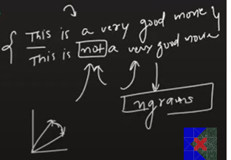

BOW will consider these two sentences as similar due to similar frequency of the words. But overall both sentences convey totally different meaning

**N-grams**

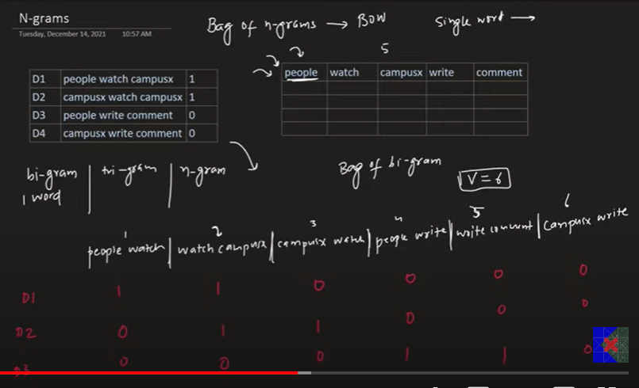

In N-grams (bi-gram,tri-gram,quad-gram) we divide the vocabulary based on some set of words to keep the order in check

Example of bi-gram:

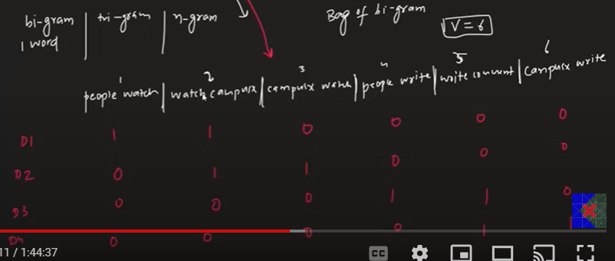

Example of tri-gram:

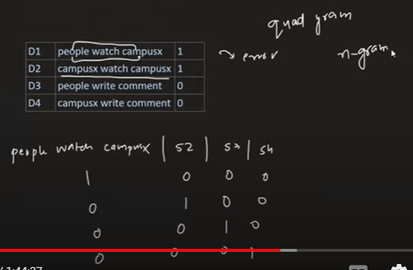

BOW is uni gram which is set by default in ngram_range parameter in CountVectorizer

N_gram = (2,2) gives bi-gram. (1,2) gives vocabulary of both bi-gram and n-gram

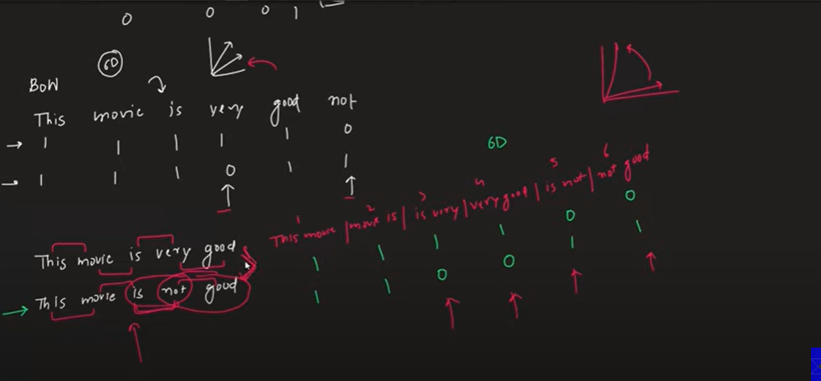

Now main advantage in using n-grams instead of uni gram is:

When we were using BOW (unigram) there were just two columns where values were different means the vector in 6-D space were relatively closer and were potentially classifying as similar sentences which is not the case

When we used bi-gram there are more columns with different values, meaning the vectors are more distant as compared to BOW vectors which gives the right semantic meaning and classify them as two different sentences

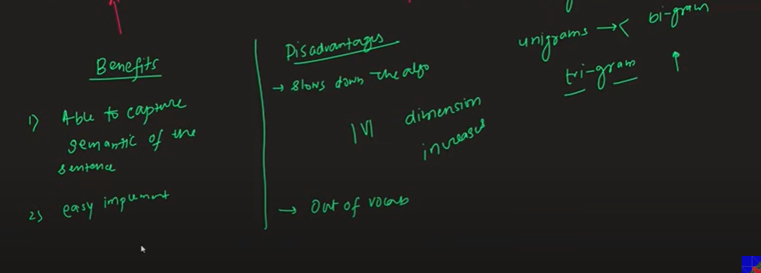

The major disadvantage in n-grams is that if we go to bi gram, tri gram the number of features starts increasing and if the dataset becomes huge, the number of features also become more leading to more computation required and makes the algorithm slower.

It still doesn’t solve the problem of out of vocabulary

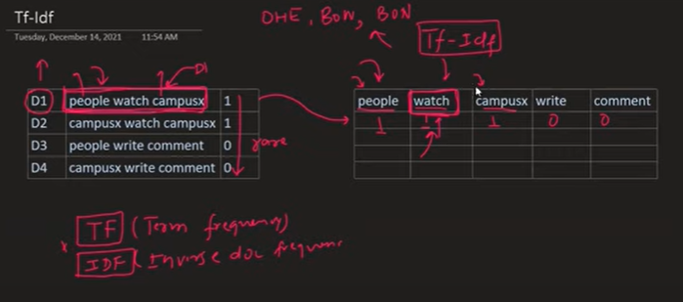

Tf-Idf provides weightage to different tokens as compared to OHE, BOW and n-grams

Suppose a word is only coming in D1 but is not present in any other documents (or whole corpus) then that word is given more weightage as compared to other words

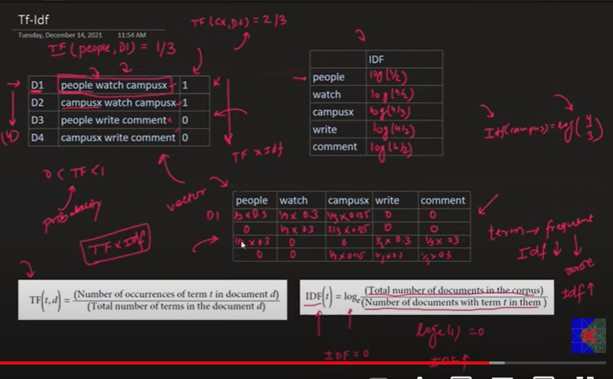

In IDF(t) we add 1 to the formula because in cases where IDF(t) becomes zero, TF * IDF also becomes zero and we don’t want that to happen

Why log in IDF formula

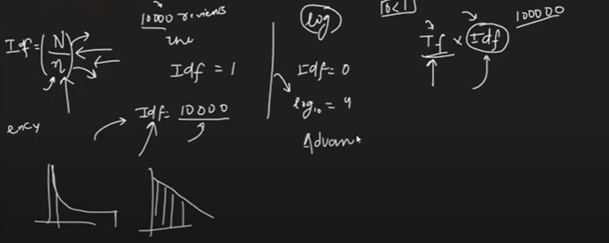

If the number of documents are higher and the word is only present in only one of the document then the value of Idf becomes higher and that will nullify the effect of Tf in Tf*Idf. Hence, we apply log to smoothen out and keep number low

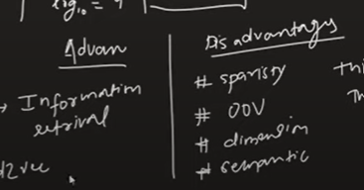

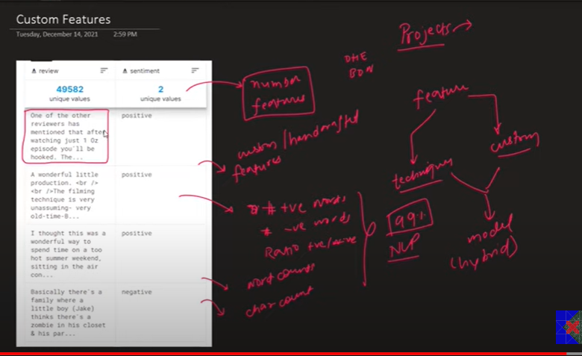

In NLP projects, we manually create custom features and also use some of the techniques discussed earlier together to get better results

# Word2vec Complete Tutorial | CBOW and Skip-gram | Game of Thrones Word2vec

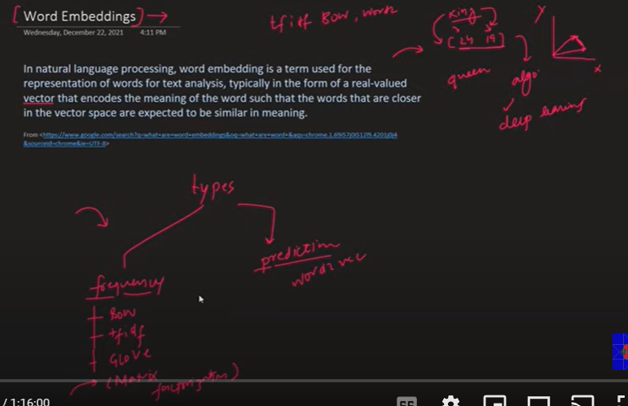

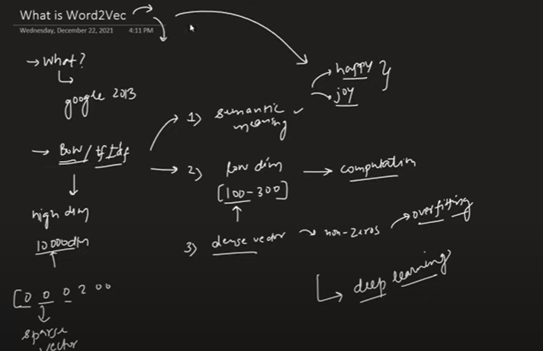

The advantage of using Word2Vec over other embedding techniques:

1. It captures semantic meaning behind the two words
2. It converts higher dimensional to lower dimensional text
3. It forms dense vector instead of sparse vectors

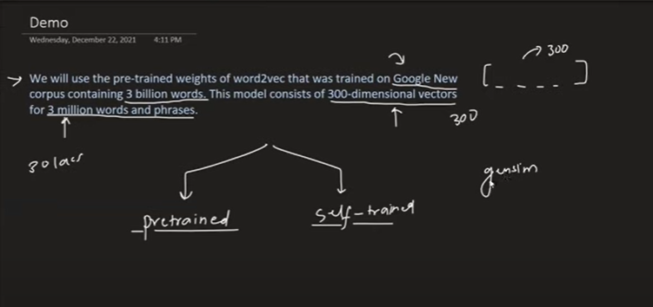

In this pretrained google’s word2vec model there is a corpus of 3 million words and each word is represented by a 300 dimensional vector

Intuition of Word2Vec

Internally, word2vec creates features for each vocabulary based on the nature. And then it assigns a value against feature for each word

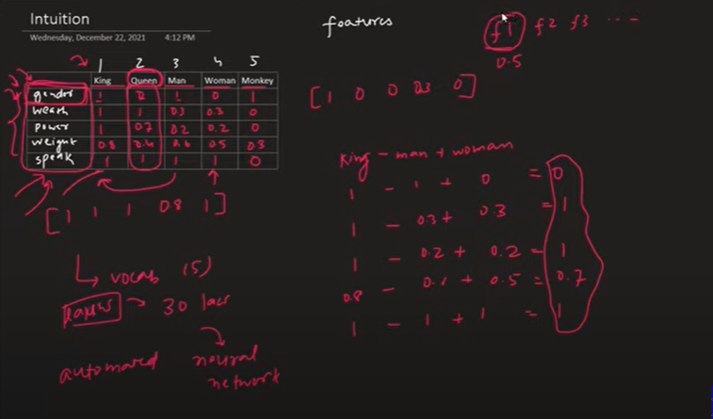

Now, creating this feature manually for all the vocabulary if the size of corpus huge is not possible. Hence, word2vec uses deep learning techniques to create features automatically but are not interpretable

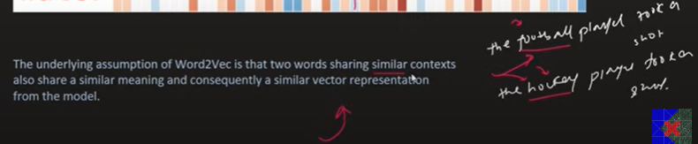

Word2vec tries to creates features and map them in such a way that they have similar contexts.

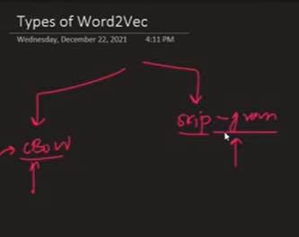

**CBOW**

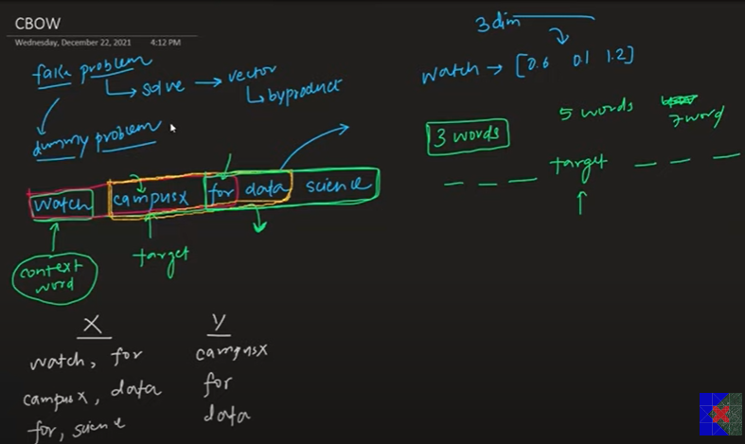

In CBOW we create a fake problem such that we can provide some context to the 3 dimension vector that we are going to define for a word

To create a fake problem we take a 3 word window (we can take any odd numbers) in which the middle word is taken as target and others are the independent variables

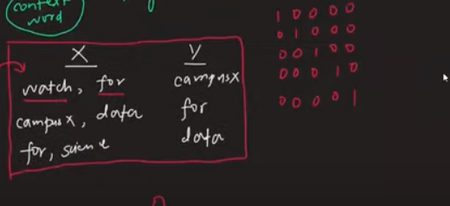

Architecture of CBOW:

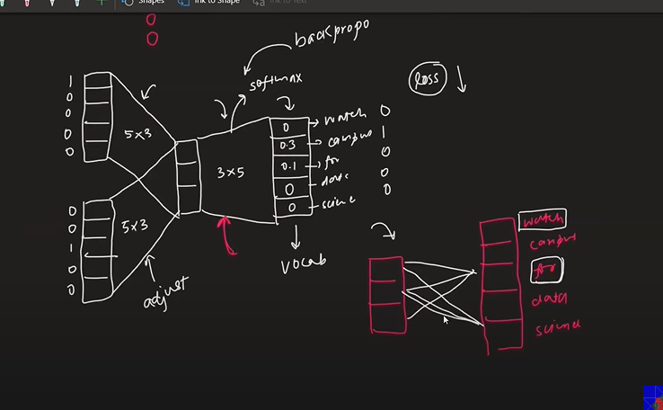

Our output is to get the vector representation of each word in 3 dimensional format

For that we train FC neural network by passing the training data that is created by a fake problem.

We pass two words with their vector representation (5 nodes each) and then have 3 nodes hidden layer and then output layer with 5 nodes with softmax as an activation function

Now we calculate the errors and then do back propagation to re calculate the weights

Our final output would be three dimensional array with weights for each word

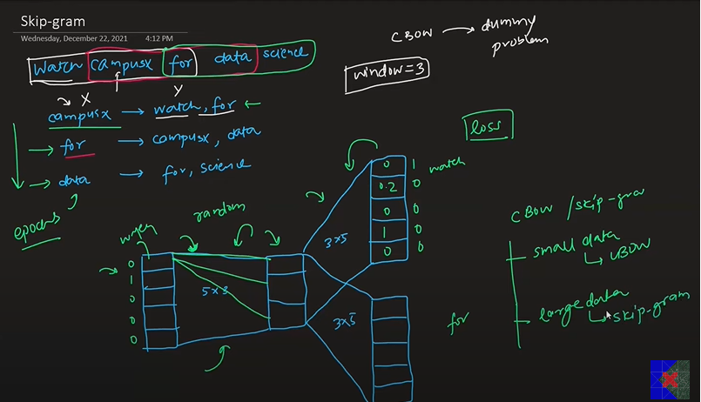

Architecture of skipgram is exactly reverse of CBOW

In skipgram the target column becomes input and other two words that were acting as predictors in CBOW now become the output column

Training process remains the same

Now the embeddings vector is generated from updated weights from input column

CBOW works better on the smaller dataset while skipgram works better on larger datasets

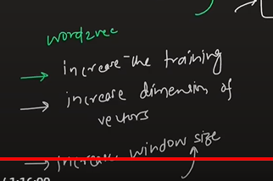

# Text Classification | NLP Lecture 6 | End to End | Average Word2Vec

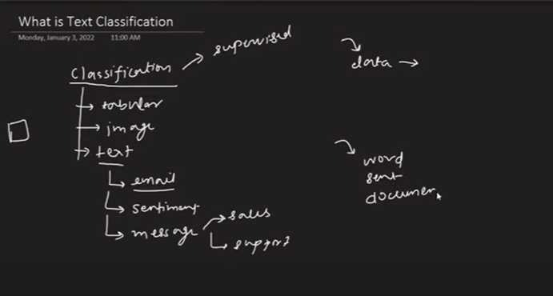

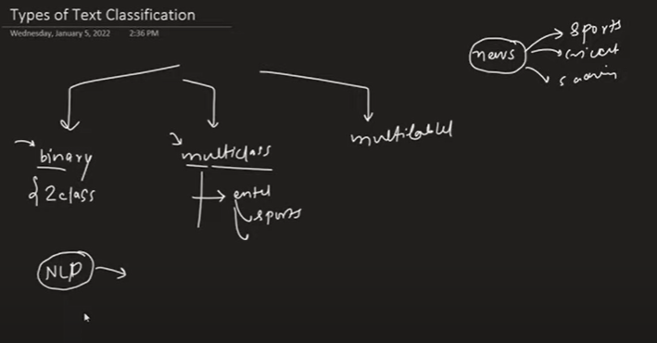

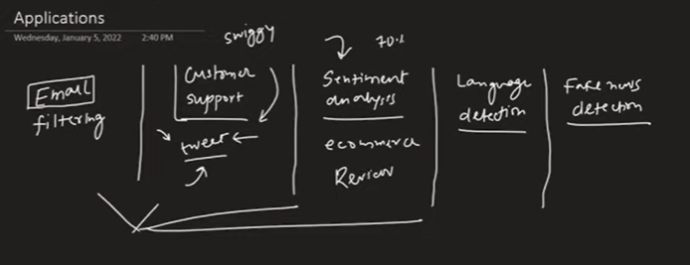

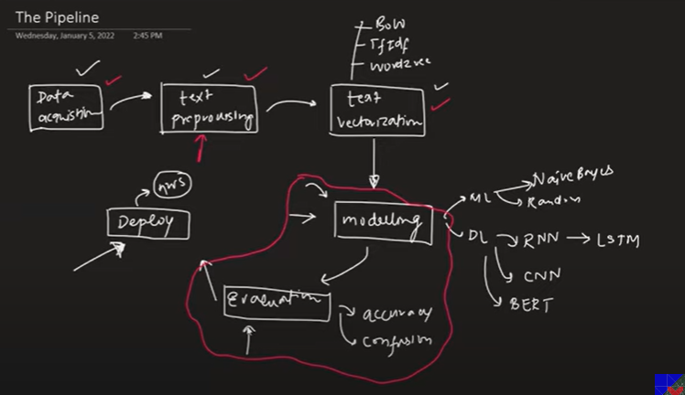

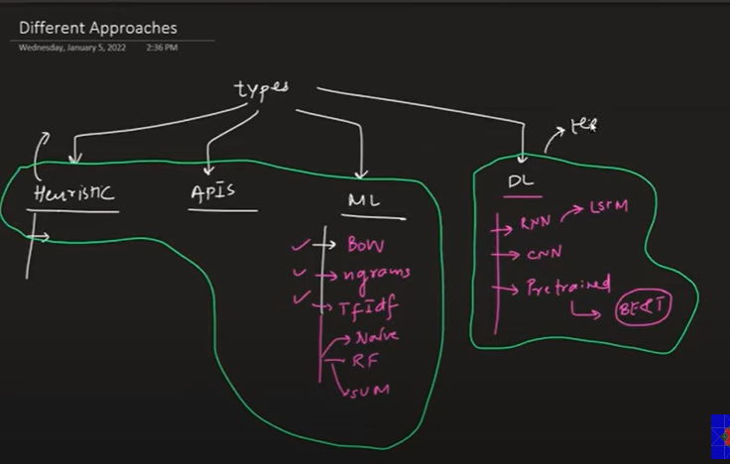

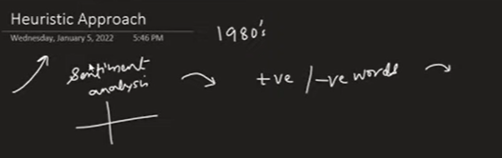

We use heuristic approach when we are working on sensitive data on which we cannot apply ML/DL models

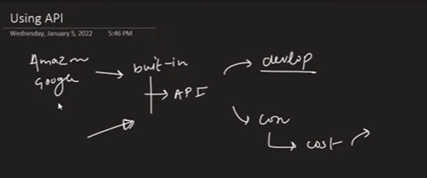

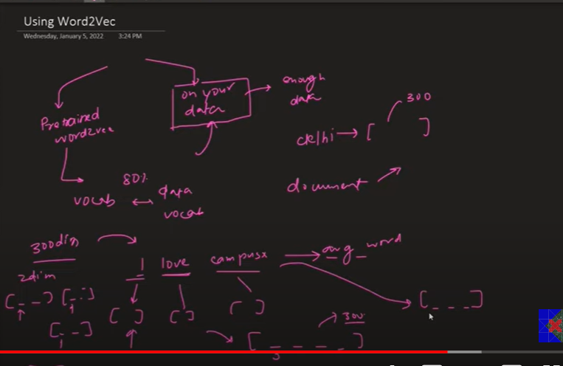

In word2vec, we represent a word into n dimension vector. But in text classification, we need to convert the whole text into n-dimension vector using Average Word2vec by adding all the number of vectors of words / total words

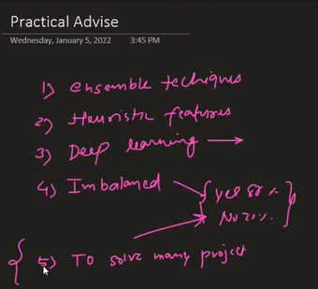

We should use ML algo before DL to get an better understanding of data

# POS Tagging | Part of Speech Tagging in NLP | Hidden Markov Models in NLP | Viterbi Algorithm in NLP

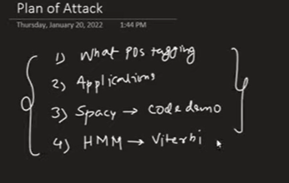

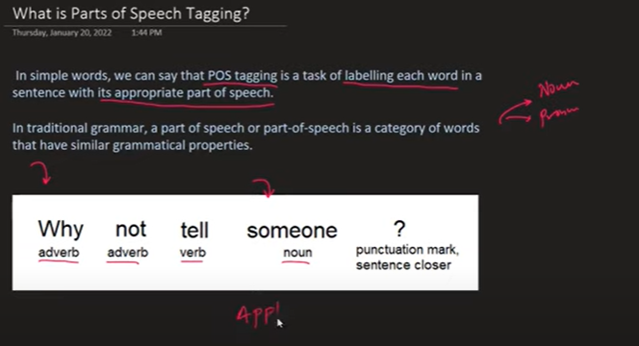

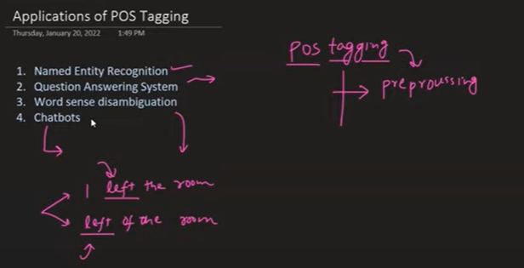

<https://github.com/campusx-official/spacy-pos-tagging>

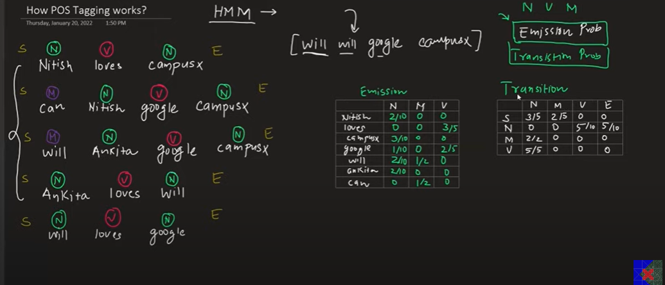

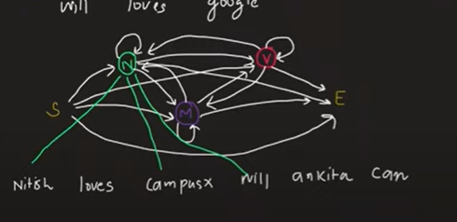

After calculating Emission and Transition probabilities, we take a sentence

We try every combination of POS and then write their respective Emission and Transmission probabilities

We multiply the Emission and Transmission probabilities and do a summation for words

Whichever combination of POS has most aggregate value after summation is believed to be accurate POS combination

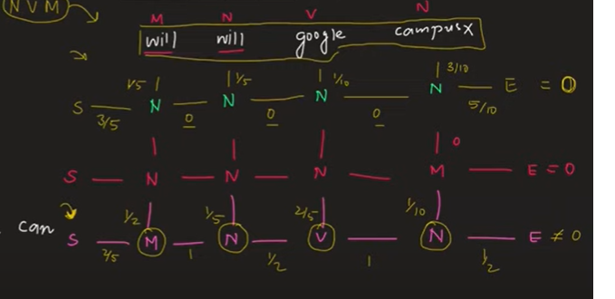

Now the problem is, if there are more words in the sentence then trying out every combination will be impossible and hence finding right POS combination will also become tough

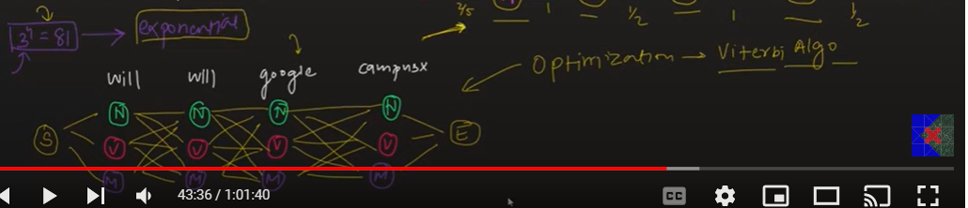

To make it more optimized we use Viterbi algorithm:

